# Lab 4-Linux Shell Scripting:

## Tasks

**Follow the instructions of your instructor and use the above concept of shell scripting complete the following.**

**Q1: Write a script to write and then read a file and view it on screen using the parameters and input from user.**

**Gedit file Code:**

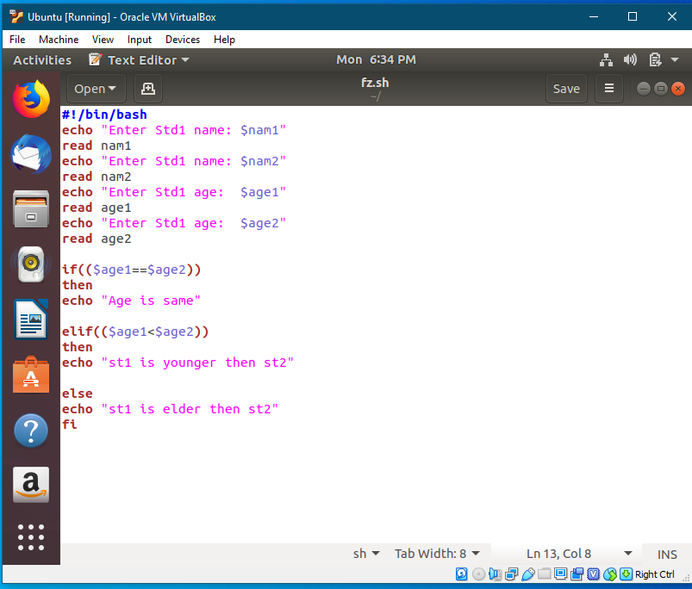

**Output:**

